BUBBLE SHOOTER Sweet Halloween

Documentation

Note: if you want to make works IAPs on windows phone update the plugin OpenIAB from there: https://github.com/onepf/OpenIAB/releases

Game have 3 modes:

0 – get to the top and collect stars

1 – rescue chicken

1. Project structure, main folders:

* Animations
* Prefabs and Resources
* Scenes
* Scripts
* Textures

All that folders contains important game datas and arts.

Resources/Levels – contains level design datas in xml and txt format.

Scripts/Bubbles – contains gameplay code.

Scripts/Effects – helpful scripts for animation

Scripts/GUI – includes animation and events of GUI.

Scripts/INAPP.cs – sku and event of IAPs. (More information about IAPs plugin <http://www.onepf.org/openiab>)

Scripts/InitScript.cs – initialization script.

Scripts/Bubbles/mainscript.cs – main gameplay script.

How to edit levels:

1. Download this useful software <http://www.mapeditor.org/download.html>
2. Double click to Resources/Levels/1.tmx

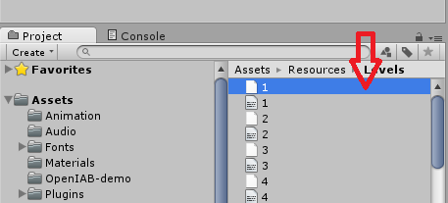

1. In opened Tiled editor go to Map/Map properties:

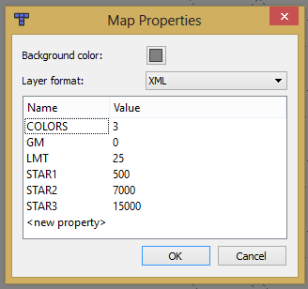

It have next parameters:

* Colors – count of colors for random color ball.
* GM – game mode. Depends from asset you bought can have:

0 – get to the top and collect stars

1 – rescue chicken

* LMT – limits of moves
* STAR1 – 3 – scores for reaching appropriate star reward.

Level have tilesets, every tileset mean one sprite for us:

 - constant color balls.

 - random color ball.

 - central ball for rounded levels (mode – 1), should be placed to the center of the level.

After placing balls you should save the file in directory Resources/Levels/, name should be just number of level.

After save you need to create txt copy of that file or use existing file with the same name (“1.txt”) if you edit levels. Because Unity can’t read tmx files from resources directory. To open tmx files in notepad I recommend you to use <http://notepad-plus-plus.org/>.

You need to open the tmx file that we created before, copy contents, past it to new file or exist file with replacing all content and save to the Resources/Levels/ folder with the same name.

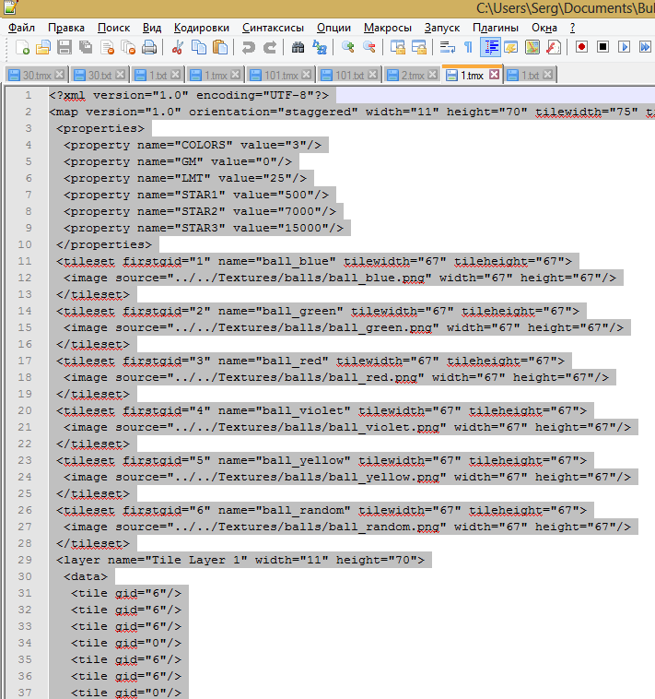

After that you have to see two files with the same names:

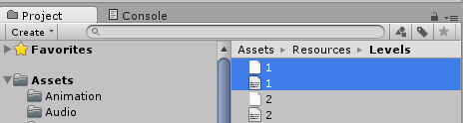

First name – for editor.

Second name – for Unity.